Student’s name
Professor’s name
Course code and name
Institution
Date
Question 3: In the Modern era, the purposes and forms of art, as well as the role of the artist, began to be questioned. Discuss some of the ways artists experimented with new styles and techniques, and how these differed from more traditional approaches. Be sure to explain how the historical and cultural context affected their art. How and why did the artist’s personal self-expression become important during the Modern period? How did this view of the artist as visionary differ from earlier understandings of the artist’s role? Include at least two specific examples of artworks (they should be discussed in your essay, and you must also upload images with captions).

Modern art includes the artwork created from the 1860s onwards to the 1970s that entails the styles as well as the philosophy of the art crafted during this period. Modern artists have experimented with several new ways associated with seeing as well as fresh ideas concerning the nature of materials alongside the functions of the art. A tendency way from the narrative primarily used as a characteristic for the traditional arts is associated with modern art. The contemporary art principally began with the heritage of painters, including Vincent Van Gogh, Paul Cezanne, Paul Gauguin, Georges Seurat, and Henri de Toulouse, among others.
Modern art is traced to the Enlightenment, which is criticized from the outside. The influences towards the contemporary art included the decorative arts from the eastern among the Japanese printmaking, the coloristic innovations of Turner in search for a dash of more realism in the description of the regular life as illustrated by the works of Jean Francois Millet. Successful painters of the day were working mainly on commission based and through public exhibitions of their work. The impressionists allude that people rarely see the objects but only the light that they reflect; hence the painters should utilize their unique painting skills to come up with paint in natural light (Tornari et al. 309).
The modern art objective is to put aside the tradition of the past as well as experiment with new ways of seeing as well as with fresh ideas concerning the nature of the materials alongside the functions of the art. It is a typical form of art that played alongside experimented with more as well as bold abstract ideas. The contemporary objective is to come up with a society focused and social community which tends to reflect on culture through the use of new technologies and materials such as the videos and technology (Baharom et al.) The traditional art is geared towards the representation of reality through the narrative in the form of art.
The materials adopted in the two periods are quite different. Modern art uses technology, including computers, 3Ds, capturing live elements and performances, among others. Traditional art used materials such as paint pencils, charcoal, clay, plaster, brush, pottery wheel, among others, to create the artwork. The critiques of modern art assert that paints had lost its artistic appeal compared to traditionalists art (Groys). Contemporary artists consider the old methods of modernisms as quite conformists and vague hence they make conclusions to make their works of art while adopting the stated materials following their styles.
Specimen (After Dürer), John Baldessari, 2000
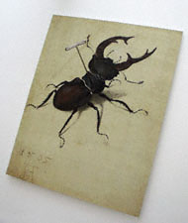
Source: https://kellyeimwrapped.weebly.com/uploads/1/0/7/2/10723518/7251914.jpg

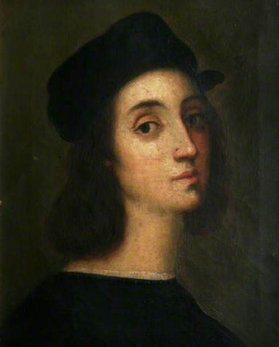
https://kellyeimwrapped.weebly.com/uploads/1/0/7/2/10723518/3219523.png?313

Work Cited
Baharom, Syarifah Nur Atiyah Syed, and Norwani Md Nawawi. "Transformation of Traditional Telepuk Motifs into Contemporary Artwork." Proceedings of the 2nd International Colloquium of Art and Design Education Research (i-CADER 2015). Springer, Singapore, 2016.
Groys, Boris. The topology of contemporary art. Durham: Duke University Press, 2008.
Tornari, V., et al. "Modern technology in artwork conservation: a laser-based approach for process control and evaluation." Optics and lasers in Engineering 34.4-6 (2000): 309-326.

